**1. Scheduling Rules**

**1.1)** Degrades

**1.1.1)** 1st slabs of tundish

**a)** 1st slabs of the 1st heat after startup should be 7D (do not plan on 6D order) or 8H and at least 25T.

**b)** 1st slab on a heat after a FTC (tundish fly) of the same spec should be a 7D or 8H.

-7D for specs with orders predominantly calling for *D conditioning codes

-8H for specs with orders predominantly calling for *H or *J conditioning codes

**c)** 1st slabs will have a 12” crop added to them by the caster computers that will be cut off at the SDF

**1.1.2)** 2nd slabs of cast

**a)** 2nd slabs of tundish cannot be better than 3D (i.e. no 2D or TD slabs)

- K201G cannot be planned better than 5D

- see section 1.1.7 below for special notes on line pipe conditioning codes

**1.1.3)** Last slabs of tundish

**a)** Last slab of a string should be a 5D/M if planned on 5D order, 8J/M if planned on 8J order, 7D if planned stock or 7D order.

-Last two slabs need to be the same width but of a different order cut in PHD Builder

**b)** If next tundish is the same grade (i.e. no intermix) this slab can be planned on a prime order if one is available with the appropriate conditioning code.

-If no prime order is available with the appropriate conditioning code then plan a stock slab with either a 7D or 8J conditioning code (as appropriate) of the same length as the customer orders.

**c)** If the next tundish is a different grade (i.e. there will be an intermix) the last slab must be a stock slab

**1.1.4)** Nozzle/shroud changes

**a)** Nozzle/shroud changes show on the 32 hour schedule as NQC, yield a 6D quality slab.

**b)** The slab following the NQC is a 5D.

**1.1.5)** Tin plate

**a)** 3SP is currently only approved to cast 6D (non clean steel) Tin for Weirton, Weirton grade 300.

**b)** 3SP is not currently qualified to cast 2D/2B (clean steel required) Tin for Weirton. Quality must approve before this can be cast.

-Tin Plate 2D/2B slabs must be planned in the middle of the heat (no first/last slabs).

**-**When available plan K203/K202A (LCAK) for 1st ht of tundish on tin with clean steel.

**1.1.6)** Ladle Exchange slabs

**a)** Do not plan a 2D or TD slab as the first slab of a heat if possible

**1.1.7)** Line Pipe

-Line pipe is scheduled differently than everything else. Because slabs do not auto apply back to line pipe orders (line pipe customer request) we only schedule degrades for the first slabs of the very first tundish and the last slabs of the very last tundish of one sequence of one line pipe grade. Keep in mind that this will cause the amount scheduled to be larger than the number of slabs we realistically expect to yield

**a)** First tundish of a string of line pipe

-1st slab 8H, not tied to order

-2nd slab 8J, not tied to order

- For the 1st and 2nd slabs the weight summation is ≥130,000 lbs

-rest of slabs 6J or 8J as defined on order, tied to order

**b)** Intermediate tundishes

-all slabs scheduled as defined on order, tied to order

**c)** Last tundish of a string of line pipe

-all but last slab scheduled as defined on order, tied to order

-last slab 6J or 8J as defined on order, not tied to order

**1.2)** Intermixes -

**1.2.1)** Plan 7Ds or 8Hs for all major chemistry intermixes (see Intermix Table) for the last slab of previous tundish, first of new tundish (95% of all intermixes).

**a)** Plan both slabs to be about 25T (or more) each for major intermixes.

**b)** For minor intermixes (no reduced cast speed) plan 50T for intermix at start of new tundish.

**c)** Minor intermix slabs should be planned on the least restrictive grade (e.g. K202 or K170).

**1.2.2)** *Chemistry Restrictions*

**a)** Ca and non-Ca grades can not be mixed in the same tundish.

**b)** B and non-B heats cannot be mixed in the same tundish

**c)** P and non-P heats cannot be mixed in the same tundish

**d)** Mo and non-Mo heats cannot be mixed in the same tundish

**e)** J225 cannot be mixed with anything in the same tundish, ever

**f)** A grade with max C < .09 cannot be mixed with any grade with min C > .14

**g)** tinplate and non-tinplate grades cannot be mixed within the tundish

-exception is when using LCAK for the first heat of a tin tundish

**1.2.3)** *Special Case Chemistry Restrictions*: these apply only when there are insufficient orders to fill a 3-heat tundish and orders are overdue

**a)** It is ok to mix any K222* series grade with any other K222* or J222A within a tundish

**b)** It is ok to mix any grade within the J260* or J261* series grade with any other J260* or J261* series grade

**c)** It is ok to mix any grade within the J262*, J264* or J266* series grade with any other J262*, J264* or J266* series grade

**1.3)** Tundish lengths

**1.3.1)** Minimum tundish length is 3 hrs of cast time, generally 3 heats but could be 4 heats when wide/fast

**-** Repeated 3 or 4 heat tundishes are not recommended as tundishes can not be made ready fast enough

**1.3.2)** Maximum tundish length varies by machine and type of grade

**a)** 1CCM maximum tundish length is 5 hours 45 minutes for CA grades and 7 hours 45 minutes for non-CA

**b)** 2CCM maximum tundish length is 7 hours

**c)** 1 heat is between 250T & 275T (500,000lbs & 550,000lbs), average around 540,000lbs.

**d)** #2 caster has faster cast speeds than #1 caster, so # of heats on tundishes will be less on #1.

**e)** Max length on K261A is 7 heats

**1.4)** Length Capabilities (all lengths are cold)

**1.4.1)** Minimum castable length is 200” regardless of width due to RTV capabilities.

-Slabs less than 200” must be doubled.

**1.4.2)** Maximum cast slab length is 460” (per Ray Puntillo) if casting double-length slabs, single slabs are limited by the hot mill:

**a)** 436” for orders rolling at the 84” Hot Mill

-84” dead zone is between 220” and 248”

**b)** 384” for orders rolling at the 80” Hot Mill

**c)** 380” for orders rolling at the Burns Harbor Slab Hot Mill (140” min)

-dead zone is between 190” – 215” (cold)

**d)** crane max capacity is 70T

**1.4.3)** On #1 Caster, slabs over 65” wide and less than 225” long must be scheduled as one long and one short

-if long slabs (over 225”) are not available double up every other short slab to be ripped at the SDF

**1.4.4)** On #2 Caster, slabs over 60” wide and less than 225” long must be scheduled as two longs and one short

- if long slabs (over 225”) are not available double up short slabs to be ripped at the SDF

**1.5)** Width capabilities

**1.5.1)** #1 caster: 80” – 42.0”

**a)** Maximum width for startup on #1 machine is currently 74” due to dummy bar alignment issues

**b)** On CA/High C/Med C grades slabs should finish around 42”

**c)** On Low C or Ultra Low C slabs will finish > 42”

**1.5.2)** #2 caster: 84” – 44”

**a)** Maximum width for startup is 64”

-NQCs must be under 80”

-FTCs and TAs must be no wider than 69” and must have 800” of slabs at 69” or less before the FTC

**1.5.3)** Minimum width for startup is 53” on #1CCM, 47.0” on #2CCM (smallest dummy bar)

-if start up width is narrower caster will ram in as quickly as possible to get to width

**1.5.4)** Widths can be planned in 0.1” increments, but 0.1” jumps are not feasible

**a)** If 0.1” jump is called for, bump the narrower width to match the wider width

**b)** 0.3” width change is the smallest feasible width change

-if necessary a 0.2” width change can be planned, but only one such jump can be planned per tundish

**c)** Currently all aim widths are calculated in 0.5” increments, except for hot roll which is calculated in 0.1” increments

**1.6)** Width Changes (Rams)

**1.6.1)** Maximum width change is 4” inward, 3” outward, but we prefer not to create a tapered slab if possible

**1.6.2)** A tapered slab is based on the difference between head and tail and is defined as:

1. 84” HSM Indiana Harbor:

* Greater than 1.3” for hard steel (D, E, & F hardness)
* Greater than 2.0” for soft steel (B & C hardness)

1. 80” HSM Indiana Harbor

* Greater than 1.2” for all grades

1. Burns Harbor Slab HSM

* Greater than 1” for  all grades
* Plan for no taper on BH slabs.  If that is not possible plan no more than 0.5” of taper.

1. Cleveland HSM

* Greater than 2.25” for all grades

**1.6.3)** Planning tapered slabs:

**a)** All unacceptably tapered slabs (as determined in 1.6.2) must be planned as either edge trims or stock slabs

-planned edge trims must be a minimum of 1” wider than the ordered slab width and must fit the edge trim rules for that grade

**b)** Tapered slabs planned on non-edge trim grades will be **scrap.**

**c)** On grades with a max trim allowance of 3”/side the maximum taper than should be planned is 2”

**1.6.4)** No more than 5 rams per heat (Level 2 restriction)

**1.6.5)** Aim not to plan more than 8” of size change per heat

**1.6.6)** Both machines can make inward and outward size changes

**a)** Can ram in and out on low C and med C grades

**b)** Can only ram in on high C and boron grades

-cannot edge trim or cut back any boron grades

-cannot ram out over 0.11 C

**1.6.7)** **Width change capabilities are outlined in section 3. Width Jump Rules**

**1.8)** VCP (Vacuum Degasser)

**1.8.1)** The VCP can make heats for either caster, but cannot make heats for both casters simultaneously (only one vessel)

-CRML grades are the only VCP grades that can run on #1 caster

**1.8.2)** These grades are VCP mandatory:

-J1XX (CRML) or K1XX (IF)

-K207 series

-K218 series

-K20X series can be degassed but not mandatory (with the exception of K208 and K209 families which are never degassed)

-any grade with Carbon < .044

**1.8.3)** These grades are extremely preferenced to degass but can be made through the LMF when the VCP is unavailable for long durations. Doing this increases the chance of making off chemistry heats:

-K235T

-K200

**1.8.3)** Refractory targets:

-maximum number of heats on one set of snorkels is 100 – 150, average is 120, replacement is 10-12 hours

-maximum heats on a bottom is 390, average is 340, replacement is 12-14 hours

-maximum heats for a vessel (including dome/elbow) is 2500, replacement is 6 days minimum

**1.8.4)** Alternating IF degass and light-treat degass

-in order to prolong the life of the VCP equipment light treat degass and IF degass should be alternated.

-aim to cast no more than 15 hours of light treat degass and immediately follow that with a minimum of 8 hours of IF degass.

-light treat degass includes K200s, K201Gs, K207s, and CRML

-IF degass includes K130A, K155, K170, and K132

**1.8.5)** Do not stay at 45” or narrower (80 minute ladles or slower) for more than 12 hours

-if this is done you must cast at 46” or wider (75 minute ladles or faster) for at least 12 hours

**1.9)** Grade Capabilities

**1.9.1)** For reference purposes, the grade families are defined as:

-Tin Plate

-Medium / High Carbon: C = 0.13 to 0.5

-Peritectic: C = 0.075 to 0.105

-Low Carbon: C = 0.015 to 0.085 (max)

-IF/ Ultra Low Carbon / Ti-Sulc : C <= 50 ppm

-Motorlam: J18X series

-High Strength / Low Alloy

-Boron and Calcium grades have a greater than 0 min for either Boron and/or Calcium and are not IF

**1.9.2)** Some specs are restricted to #1 machine or #2 machine, some can run on either machine

**a)** #1 caster is a curved mold machine, #2 caster is a straight mold

**b)** No CA grades allowed on #2 caster

**c)** LCAK can go on either machine, but if cast on #1 there is a possibility of pencil pipe, requires approval

**d)** IF must go on #2 machine due to the straight mold

**e)** **For a list of specs that cast on each machine see *3SP Scheduling Rules Addendum***

**1.9.3)** Due to the price, Chrome (Cr), Molybdenum (Mo), and Vanadium (V) are not generally stocked and must be ordered

**a)** See Supplemental table for grades

**b)** Call 3SP procurement analyst to order alloys

**1.9.4)** 3SP does not cast any 300 or 400 series specs or grades that end in H (H = HIC)

**1.9.5)** Boron and Antimony (Sb)

**a)** Do not intermix boron or antimony grades with tin grades

**b)** Do not cast J212X grades immediately before or immediately after a boron grade

**c)** Do not cast boron grades on #2 (e.g. K218A or K207E) while casting line pipe on #1. This is to avoid cross-contamination.

**1.9.6)** If you are unfamiliar with a grade and it is not on the 3SP Scheduling Rules Addendum as an approved grade check with 3SP Quality to make sure they are able and ready to make it before scheduling

**1.10)** Off Chemistry Inserts

**1.10.1)** When an insert is needed it must meet minimum tundish requirements and then fly into a new tundish to reduce intermixing

**1.10.2)** For high N inserts use the grades below depending on the N level:

**a)** N under 0.0065: K200-K200C, K201, K201B, K201E, K201G or specs in b-d

**b)** N under 0.0070: K203 or specs in c-d

**c)** N under 0.0080: K201D, K202A or specs in d

**d)** All other N ranges use K202, K239, or K200R. On 1CCM you can also use K261A (not on 2CCM)

**1.10.3)** For high P inserts use the grades below depending on P level:

**a)** P between 0.03-0.05: J183C

**b)** P between 0.06-0.09: J188

**2. Planning/Scheduling Aims**

**2.1)** Scheduling is tundish based

**2.1.1)** Due to tundish based scheduling, do not plan late slabs in last few slabs of the last heat as they might not be cast

-if the shop makes an excess slab it does attach to the last order in the heat

**2.1.2)** Due to TBS when planning a tundish to fly near the upper limits of the machine the average heat size should be planned at least 10T less than the current after produced heat size

**2.2)** Width jumps and ripping

**2.2.1)** To avoid tapered slabs

**a)** Hard steel (D, E, and F hardness) width jumps should be planned as no more than 1.0” of taper

**b)** Soft steel (B and C hardness) width jumps should be planned as no more than 1.5” of taper

**2.2.2)** Ripping slabs

**a)** PHD Builder automatically adds 0.5” of width for torch loss on ripped slabs

**b)** When planning rips slab length ranges must overlap

**2.3)** Macro Etches and Buff Checks

**2.3.1)** All J26X grade specs 6J or 8J conditioning code require 1-2 macro etches per tundish

**a)** 1 / tundish (1st prime of tundish) for every tundish until last pipe tundish, then last prime slab required macro

**b)** These show up 2CHS – hold for macro etch and take at LEAST an additional week to resolve

**2.3.2)** All J26X and J225 grades have audit buff checks

**a)** One audit per tundish; not holding up any additional slabs

**b)** If crack predictors triggered, whole heat can be released when one slab passes buff check

**c)** If possible cast pipe orders one week ahead of safety stock week to allow time for testing

**2.4)** Hot Charges

Hot charges are slabs that must be loaded into the hot mill furnaces in 48 hours or less after casting or they are scrapped

**2.4.1)** Grades J219A and J229 are mandatory hot charge

**2.4.2)** Hot charges should be scheduled to cast between Sunday night and Thursday night so that all the right people from quality and planning are available to resolve issues with the slabs

**2.4.3)** Hot charges must be coordinated with the 84” HSM and the 84” scheduler, if the caster is delayed more than a few hours from the plan and the hot mill cannot react the hot charge should be rescheduled

**2.4.4)** Make sure the ATM (automatic torch machine) is available when hot charges are cast so that if slabs are cast too long for the HSM furnaces they can be cut back and rolled

**2.5)** General caster scheduling/planning notes

**2.5.1)** When scheduling linepipe, plan at least 10% excess to account for losses at casting and hot rolling

-Always double check with the ISR for the order to see how much is due on the orders. Once we start producing on a large (over 4,000T) order the system does not accurately reflect what is really due to the customer.

**2.5.2)** Due to shipping time from east to west, schedule orders rolling at the East 80” HSM one week in advance when possible

**2.5.3)** After a Blast Furnace outage need LCAK or J188 heats when other metal is not available for blending

**2.5.4)** When the incoming iron is too cold we cannot make J225 due to inability to desulf the cold iron low enough.

**2.5.5)** Do not schedule BH Slab orders in K132 heats

**2.5.6)** In order to increase the availability of the LMF alloy system and reduce slab degrades due to late connections and slow speeds:

a) When we are making CRML on 2CCM we should not also be making fast heats (cast times of less than 60 minutes) on 1CCM.

b) We should not be making fast heats (cast times of less than 60 minutes) on both 1CCM and 2CCM at the same time.

c) If it is not possible to do this by making a schedule change a discussion should be had with 3SP management to determine other options.

**2.6)** Scheduling new grades

**2.6.1)** When scheduling a grade that has not been produced in the past, schedule only one tundish on **day turns only**

- This will allow QA and OpTech to evaluate the new practice

**2.7)** Machine-critical grades

**2.7.1)** Machine-critical grades are grades which need a roll gap meter sled run to ensure the machine is in good condition

- Typically run every 8-10 days for conformance

- A roll gap meter is considered in conformance for 10 days after being run

**2.7.2)** The following grades are machine critical and should not be scheduled to cast at 3SP unless the Caster Manager verifies that the machine is in good condition with a roll gap sled run (and any necessary adjustments made) within the previous 10 days:

- J219*, J225*, J258*, J26**

**2.7.3)** The following grades are acceptable to run on #1CCM without having a roll gap meter completed within the previous 10 days:

- K202*, K203, K239, K210*, K211*, K261*, K262*, J18**

**2.7.4)** All other grades not listed, should be considered machine critical until they are verified by the Quality department as non-critical**3. Width Jumps Rules**

1. **General:**
   1. Width transition occurs on the slab with the narrower order width near the projected torch cut. Figure 1 shows where the width transition should start depending on direction (outward or inward)
   2. Outward width change is aimed to finish at the tail end of the slab. Inward width change starts at the head of the slab. An outward width change takes twice as long as an inward width change.
   3. Table 1 provides the required length needed to make a certain width change. If the required length is longer than the order length, that width change cannot occur on that slab alone. You will have to use a stock slab for that width change or plan for an allowable taper or edge trim slab.
2. **Scheduling width changes:**
   1. **General:**
      1. Caution: any width change greater than 1” outward or 1.5” inward requires lengths that may be as long as a slab. Check slab length against Table 1.
      2. The width change will occur on the slab with the narrower order width. The start location depends on the direction, outward or inward. Refer to Fig 1.
      3. For an outward width change greater than 3.2” requires lengths that may exceed the maximum length limit for slabs depending on the hot mill. Maximum length for caster is 460”.
   2. **Tundish Fly or Startup: Due to safety, machine capabilities and tundish based scheduling; the following restrictions must be followed. Refer to Figures 2-4.**
      1. On 2CCM, the width must be ≤69 inches, 800 inches before a tundish fly. Refer to Figure 2.
      2. The first slab of a tundish has a reduced width change capability. There is a 250” safety factor implemented for width changes after a tundish fly or startup. Refer to Table 1 for required lengths.
      3. The last two slabs of a tundish should have the same order width. This is due to tundish base scheduling.

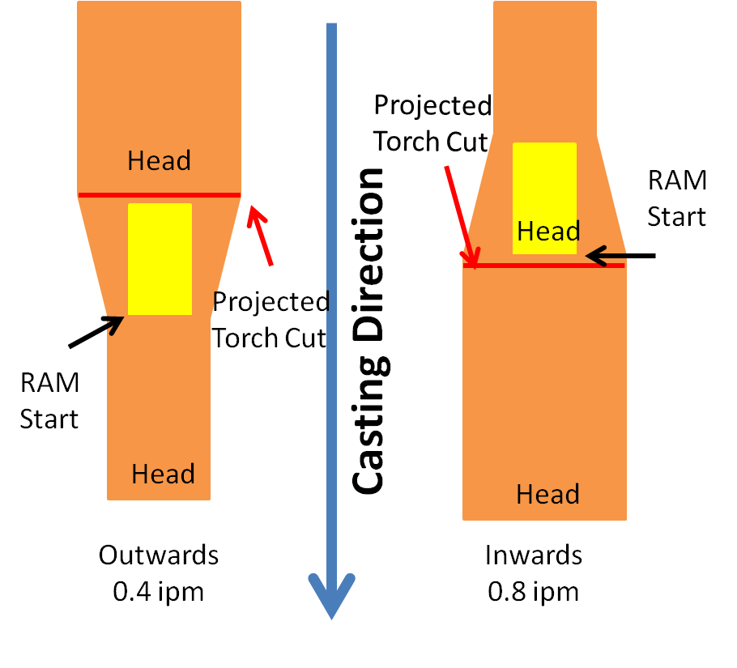

Figure 1: Left image shows an outward width change. Width transition finishes near the tail end of the narrower slab. Right image shows an inward width change. Width transition starts at the head end of the narrower slab.

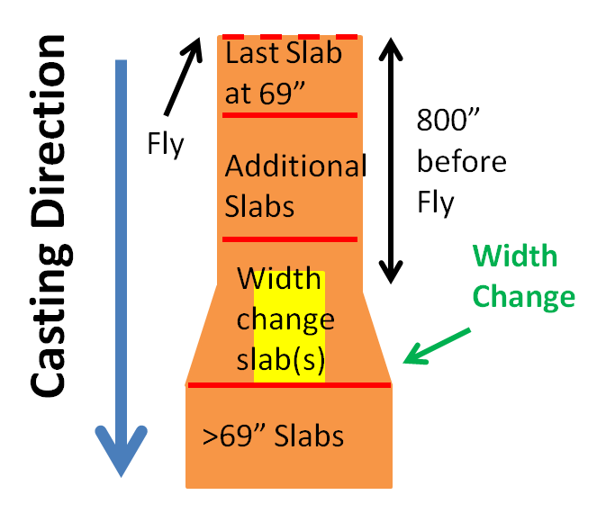

Figure 2: On 2CCM the slabs have to be ≤69” before a tundish fly. The left over slab without the width transition and additional slabs must be >800” before a tundish fly.

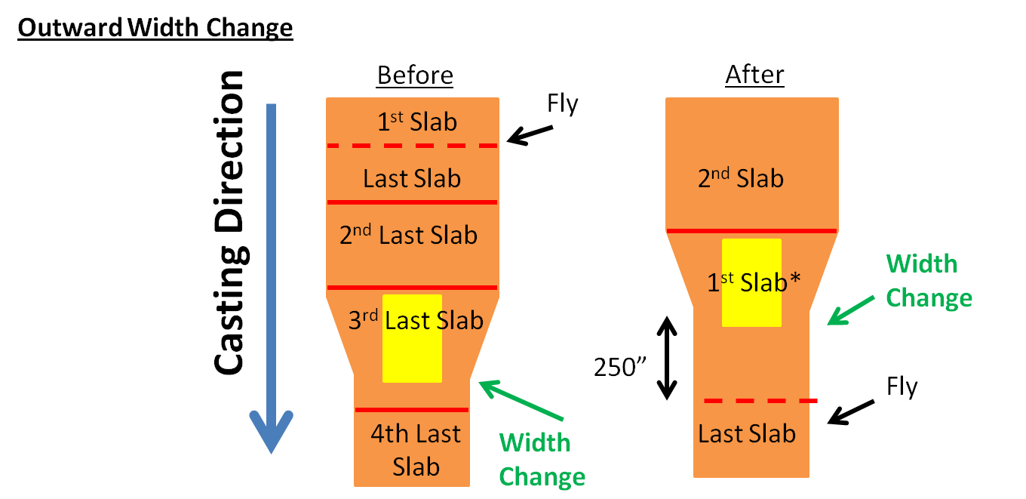

Figure 3: Outward width change around a tundish fly. *Limited width change

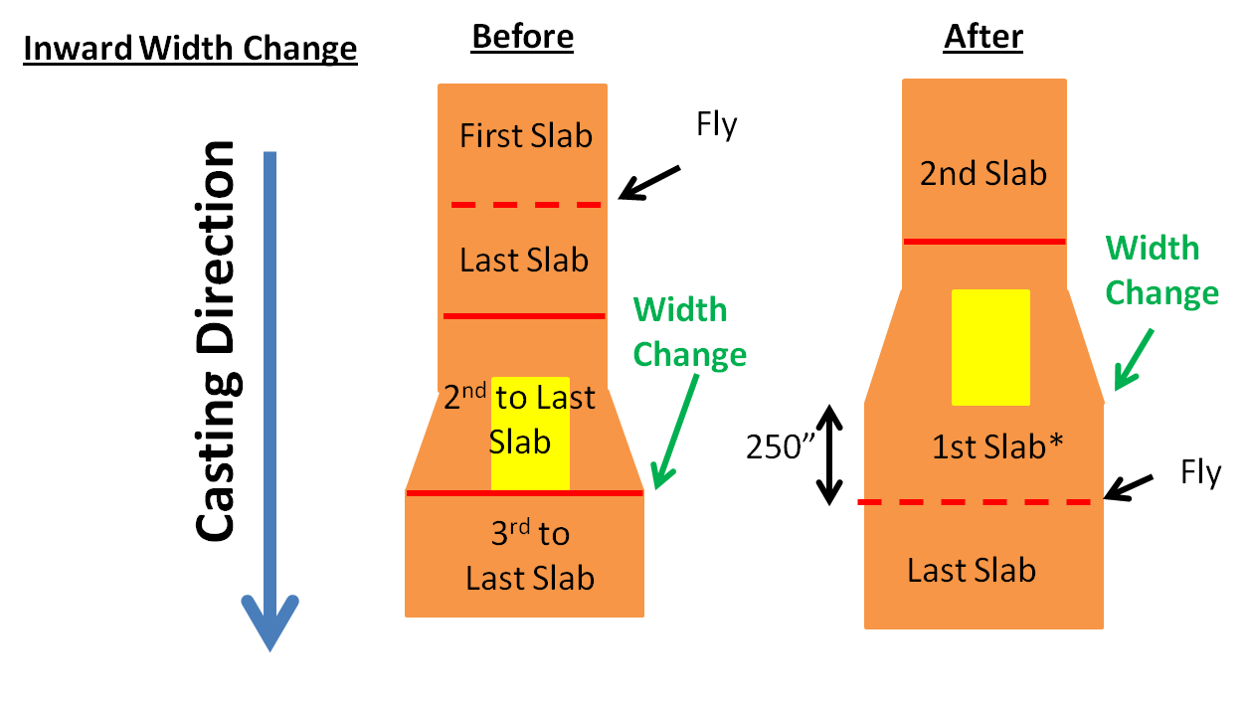

Figure 4: Inward width change around a tundish fly. *Limited width change

Table 1: Shows the required length of slab needed for an inward width change on 1CCM and 2CCM and an outward width change on either machine. There are two categories; General and 1st slab of a tundish. The numbers in yellow are required lengths that may exceed the maximum length of slabs depending on hot mill, and the red numbers exceeds the maximum slab length for 3SP, 460” (section 1.4.2). Refer to equation on the right for width changes not included in the table.

|  |  |  |  |  |  |  |  |
| --- | --- | --- | --- | --- | --- | --- | --- |
|  |  | **General** | | | **1st Slab of a Tundish $$Length=\frac{\left(∆_{width}\right)\left(cast speed\right)}{\left({rate}_{∆width}\right)}+SF$$**  Inward:   * Cast speed   + 1CCM = 50ipm   + 2CCM = 55ipm * RateΔwidth = 0.8ipm * Safety factor = 60   Outward:   * Cast speed = 45ipm * RateΔwidth=0.4ipm * Safety factor = 60   1st Slab:   * Safety Factor = 250” | | |
| **Width Change (in)** |  | **Inward (0.8ipm)** | | **Outward (0.4ipm)** | **Inward (0.8ipm)** | | **Outward (0.4ipm)** |
| **1CCM** | **2CCM** | **1CCM** | **2CCM** |
| **0.3** | **Length required (inches)** | **80** | **80** | **90** | **270** | **280** | **290** |
| **0.5** | **90** | **90** | **120** | **290** | **290** | **310** |
| **1** | **120** | **130** | **170** | **320** | **320** | **370** |
| **1.5** | **150** | **160** | **230** | **350** | **360** | **420** |
| **2** | **190** | **200** | **290** | **380** | **390** | **480** |
| **2.5** | **220** | **230** | **340** | **410** | **430** | **540** |
| **3** | **250** | **270** | **400** | **440** | **460** | **590** |
| **3.5** | **280** | **300** | **450** | **470** | **500** | **650** |
| **4** | **310** | **340** | **510** | **500** | **530** | **700** |

*revision 5 changes in blue